IRIS Operations Status
Preparation for IRIS TWG Operations Meeting of Tuesday 15th September
Apologies:
Announcements:
1) The IRIS service desk is currently operating.
If you want to request information, search for the point of contact in IRIS, want to request a change in allocation, or escalate an issue, please send the ticket to:
iris-support@stfc.ac.uk
2) IRIS is exploring an exciting opportunity through ALC to provide our community with access to Google Cloud resources, including Vertex AI.
If you're interested in using this capability, please register your expression of interest either by raising a ticket with the service desk or by emailing Deniza directly.
To acknowledge the use of IRIS resources in a publication, please use:
This work used IRIS computing resources funded by the Science and Technology Facilities Council.
Training Opportunities:
Add any workshops or training opportunities in here as soon as you are aware of them and we will add them into the IRIS Calendar:
Add a bullet for anything you think is interesting: when/what/URL
Upcoming IRIS TWG Talks
- Tue 22nd September - Public Cloud for AI and computing resource - The STFC Google Platform - Paul Quinn, STFC
We are pleased to confirm the IRIS Collaboration Meeting has now been booked and will take place on 20th - 21st October at the University of Glasgow. Registration Closes on 30th September.

Activity Status
Usage info format xxx 6130 core months last calendar month - (this month - extrapolate to full month) - [allocation]. See infrastructure section to see accounting limitations. This includes account information from SCD, GridPP and DiRAC(OpenStack Only) (excludes DiRAC SLURM)
2023 Allocation Status:
Unknown Status 🔵🫥 Not received Yet 🔴😭 Partly received 🟡😐 Received 🟢😎
Activity  (Alloc Status) | Status (dd/mm/yy [reported by]) text
CASU  😭 | 22/07/25 [AlirezaM] We were informed on 18 July about a planned critical upgrade (21–25 July) affecting IRIS (GAIA and SKA), but no mention was made of other IRIS‑hosted systems such as CASU.Since yesterday (21 July), the entire ARCUS cloud appears to be down. As we were not notified of any IRIS‑CASU access interruption, we were unable to migrate critical services. Please confirm the current status and planned actions for ARCUS and IRIS‑CASU.  18/03/26 [DenizaC] activity reported OpenStack MetadataService(169.254.169.254) Unreachable on CASU-ARCUS Kubernetes Cluster
EUCLID  😐 | 4/8/26 [MarkH] All optimal.  18/8/26 [MarkH] All optimal.  15/9/26 [MarkH] All optimal.
Gaia Data Mining Platform  😐 | 23/06/26 [MI] Main platform currently offline, under investigation. Doesn’t currently look infrastructure related. Ceph related issues at RAL, hoping will be resolved this week  07/07/26 [MI] Main platform on Somerville back up. Still some lingering cinder/ceph issues at RAL, under investigation  21/07/26 [MI] Somerville services fine. Still experiencing problems at RAL with cinder volumes that predate the ceph cluster incident not detaching / reattaching to VMs cleanly. Doesn’t appear to affect new volumes, so planning to migrate all data onto new volumes and force delete the old ones  18/08/26 [MI] Migration from old cinder volumes at RAL almost complete. Otherwise no issues to report, services running ok  01/09/26 [MI] Production services on Somerville running fine. Upgrade of kubernetes cluster for EUCLID at RAL failed, currently in process of redeploying service
Gaia Core Processing  😭 | 21/07/2026 [PatrickB] Arcus cloud back online Monday 13th July. A couple of issues getting instances back up but these were quickly resolved. All working fine since then.  04/08/2026 [PatrickB] Arcus cloud resources operating normally.  18/08/2026 [PatrickB] No issues to report.
LSST:UK  😐 | 4/AUG/26 [George B]  - HT-Condor testing is going well. Some teething troubles with Rubin desire to switch some Rucio SEs to DAV:// (instead of HTTPS://).  - Data Preview 2 being transferred to UK DAC.  - Setting up DP2 user-generated processing on CSD3.  18/AUG/26 [George B]  - Rubin Early Data Preview 2 has been published and distributed to data access centres using Rucio and (RAL) FTS.  - DP2 data being used for DRP scaling tests at RAL and Lancs, exposing some scaling issues with file system and science metadata services.  - Project use of STFC Research Cloud refactored into four activities using IRIS IAM groups (to avoid noisy neighbours).  - Arrival of EDP2 will mean more processing campaigns on CSD3 in coming weeks.
JBCA (e-MERLIN ALMA)  😎 | 3/2/26 [AntH] New IRIS storage arrived.  9/6/26 [AntH] No issues  21/7/26 [AntH] No issues
SKAO  😎 | 22/07/25[UY]: Recovering from the STFC outage. Had some issues with Manila but seems to be in upwards trajectory and stability  17/03/26[UY]: No issues  14/04/26[UY]: Struggled a lot with VM Flavor availability this month. Having visibility of the existing flavors would help a lot with planning and maintenance going forward. No other issues.
LZ  😎 | 04/08/26[DB] Production ongoing, users having been helped.  01/09/26[DB] Production ongoing, no problems observed.
JLAB/CLAS12/GlueX  😎 | 30/05/23 [BMK] Jobs not currently running. VOMS failures verifying the attribute certificate. Ticket open and active with OSG support.  16/09/24 No major issues other than fluctuations in the job pressure coming from JLab and the disappearance of the local patch which allows token jobs to run in ARC6. This issue is known and will (should be resolved) in ARC7.
MicroBoone/SBND  😎 | 04/08/26 [DB] We are trying to set up opportunistic CPU resources for SBND in the UK, but the pilot at Imperial has stalled due to lack of input from the experiment:  https://support.opensciencegrid.org/support/tickets/public/b701125402139baac4a4d798c82efe571e7357b93601c259affc744dee644f40
DUNE  😎 | 30/09/25 [Wenlong Y] DUNE is making good use of UK storage, currently is at 5 PB, following the protoDUNE data taking a few weeks ago.  14/10/25 [Wenlong Y] GridPP is investigating DUNE low FTS rate (<1MB/s) from CERN EOS disk to QMUL, Glasgow, Lancaster, Manchester RSEs, while RAL_PP, RAL_ECHO are ok.  20/01/26 [Wenlong Y] All UK sites are ticketing to move to token support, due to DUNE InCommon host Certs will not be allowed for user auth.  05/26/26 [Wenlong Y] 500TB RAL tape has been added to DUNE Rucio, and working well.
PLATO  😐 | 21/07/2026 [PatrickB] Arcus cloud back online Monday 13th July. One host had network issues affecting four instances but this was resolved quickly. All instances back up and running normally.  04/08/2026 [PatrickB] No issues to report. Everything working well.  18/08/2026 [PatrickB] No issues to report.
DLS  😐 | 17/02/26 Patching for Munged CVE.  02/03/26 Nothing to report  14/04/26 Nothing to report  23/06/26 Recovery from STFC data center outage, took approx 3 hours. Minor intervention needed from STFC to fix one hypervisor. All but one instance back to normal.  01/09/26 Nothing to report
ISIS  😐 | 12/08/2025 Business systems (FASE) and IDAaaS were all affected by the Cloud network issues during July. This caused major issues for our facility users and instrument scientists. This is being followed up via service impact/disruption statements from ISIS.  8/9/2025 ISIS back in cycle from 9/9 until 17/10
CCP4  😎 | 03/03/26 [VU] Working well.  28/04/26 [VU] Working.  12/05/26 [VU] All good.  09/06/26 [VU] Minor issues with loadbalancers last week, but now all good.  01/09/26 [VU] All good.
CLF-OCTOPUS  😐 | 02/09/54 [DJR] Good progress being made migrating to RH9-based version of SLURM cluster. Still awaiting configuration of our full resource allocation..
CLF-Other 😐
JINTRAC  😎 | 09/06/26 [AL] Some VMs not working over the past few days due to the storage problem on the STFC cloud, but now fine.  23/06/26 [AL] All ok.  07/07/26 [AL] Nothing to report.  21/07/26 [AL] All ok.  18/08/26 [AL] All ok.
LIGO  😎 | 04/08/25 [DuncanM] Issue with Virgo VOMS certificate impacting ARC CE, LIGO computing working with site providers  11/11/25 [DuncanM] All ok  16/02/26 [DuncanM] All ok  16/03/26 [DuncanM] All ok  30/03/26 [DuncanM] All ok  07/07/26 [DuncanM] All ok  18/08/26 [DuncanM] All ok, think all CEs now supporting SciTokens instead of Virgo VOMS - thanks!

Capacity and Usage
Usage is available in the Accounting Dashboard (https://accounting.iris.ac.uk/) using IAM.
Note: The changes to the capacity and allocation numbers starting from October 2025 are due to a shift in measurement units. IRIS's actual capacity was reduced in 2025. During the allocation years 2024/25 and 2025/26, the average utilisation of the nominal capacity exceeded 80%. We are currently reviewing how to present this data in the most consistent manner.
Last publish time for each site available here [note that some data can run on a delay of a couple of days in this view, so only consider it an issue if a site is shown as not publishing for ~4 days]: https://apel-validation.stfc.ac.uk/iris/
- DC: Updated 01/09/2026

Current estimated usage at end of month (kilo-cores): no estimate yet
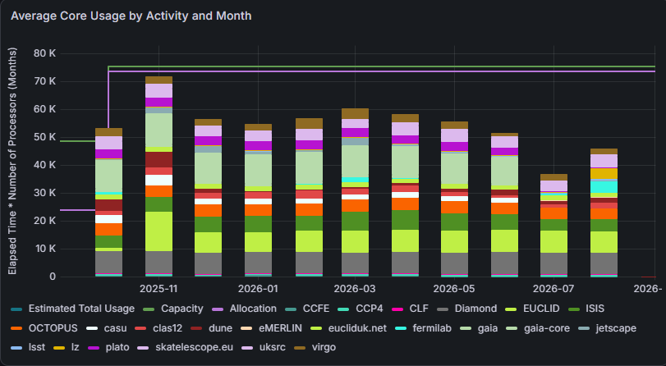
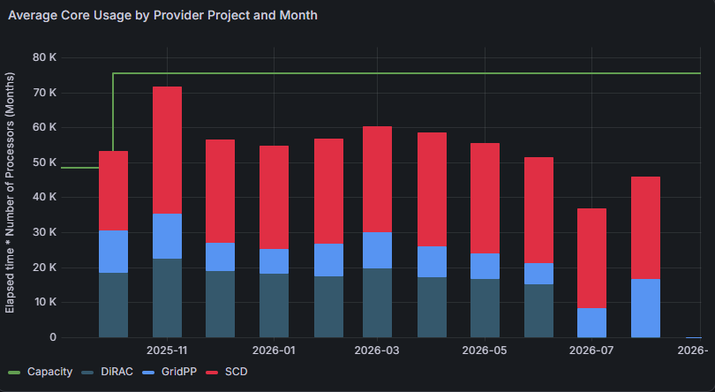

July | 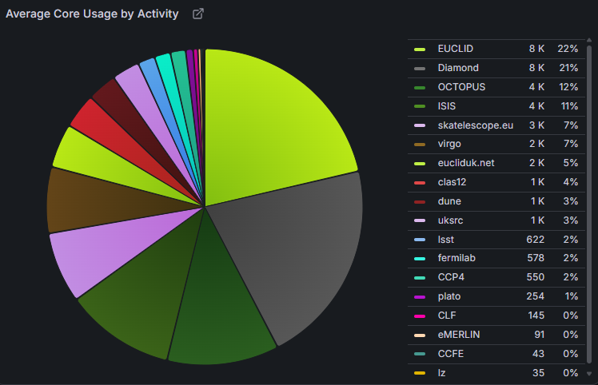
August | 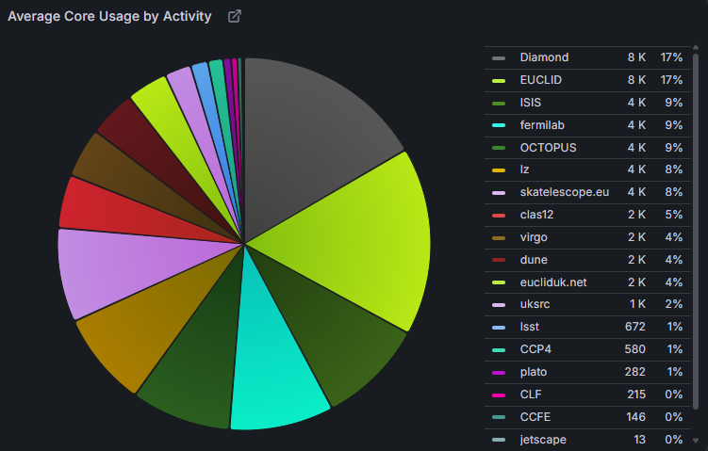

IRIS Security
Trust and Security +  Operations | 26/05/2026  - Very busy period for patching over the last few weeks, but sites have responded well to the challenges.  - EGI CSIRT meeting last week, UK well represented.  - CERN Computing Security School registrations open: https://indico.cern.ch/event/1668137/overview  07/07/26  - Couple of nasty vulnerabilities out - CVE-2026-53359 (januscape) affecting KVM VMs and CVE-2026-46242 (epoll) effecting EL 9 and 10 kernels and others. Both rate “high” but potentially greater risk in our environments.  18/08/26 (MD)  - Some of the last fortnight’s round of vulnerabilities that might affect the community:  - CVE-2026-17106 - “copy escape” affecting docker  - CVE-2026-64561 - “zapscape”, affecting KVM virtualisation  Patches are available for both (refer to docker updates and your distro’s release pages).  - Anyone running a rucio service is encouraged to update and restart due to a security bug, the details shared within the community (no CVE).

Infrastructure Status
We should also pick up any operational issues with major IRIS components here.

Middleware
DIRAC | 04/08/2026[DB] Business as usual  01/09/2026[DB] Business as usual

Federating Services
Services maintained by the Federating Services group at RAL.
Federating Services - general | 06/01/2026 [AC]: Two ~day-long periods of underlying database outage around Christmas period affected all fed services to varying degrees. All services are fully recovered. Waiting on post mortem from Database Services team.  04/08/2026 [AC]: Ongoing issue with accessing iris.ac.uk addresses from within RAL network since domain ownership changed.  18/08/2026 [AC]: Nothing to report  15/09/2026 [AC]: Nothing to report
IAM | 01/09/2026 [DC]: All green, Nothing to report  15/09/2026 [AC]: Upgrade to INDIGO IAM v1.14.3, tentatively scheduled for 13 October, 2026 0830AM - 0930 AM, At-risk, less than 5 min interruption of service expected.
IAM Hourly Availability 01/09/2026 - 15/09/2026
All green.
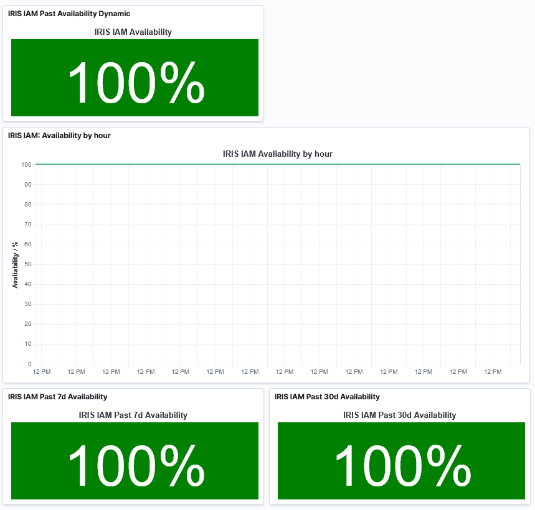
APEL and IRIS Accounting Dashboard  Publishing status: https://apel-validation.stfc.ac.uk/iris/ | 18/08/2026 [AC]: Nothing to report  01/09/2026 [AC]: Nothing to report  15/09/2026 [AC]: Nothing to report
GOCDB | 03/02/2026 [GC]: All non GridPP IRIS providers are in GOCDB, complete with security contact information: https://gocdb.iris.ac.uk/portal/index.php?Page_Type=Sites. A number of GridPP IRIS sites have tagged themselves and I am working to chase the others.  07/07/2026 [GC]: Cambridge (Cumulus) info added to GOCDB, still chasing GridPP (via Sam) and ral-scraf  03/08/2026 [GC]: Nothing to report  18/08/2026 [AC]: Nothing to report  01/09/2026 [RC]: Nothing to report  14/09/2026 [GC]: Nothing to report

Sites
CAMBRIDGE | 01/09/2026 [Stuart Rankin]:  Normal service - no exceptions. Kernel security patches being applied ever more frequently to the HPC cluster, a new round of which is currently underway. Slurm maintenance and HCT testing will take place tomorrow 2nd September 07:00-12:00, affecting HPC only.
RAL | STFC Cloud 15/09/2026 [Martin Summers]  -New “l8.amd” and “l8.intel” flavors released to specific IRIS projects (Do let Deniza or me know for access to these !)  -Work progressing on 2023-vis-GPU hosts: Hosts have OS on them, and now need integration work to be adopted in dev-cloud for flavor sizing and GPU passthrough testing.  - EOL for our dep-l2 flavors by end of October is still on track (our dell-2019 hypervisor retirement)  -  STFC Cloud 01/09/2026 [Martin Summers]  -Notifications released about 2 issues: 1: Retirement deadline of 31st October for VMs using “ l2 flavors”(and variations) - Dell 2019 Hypervisor kit.  2: Notification in regards to an issue found with re-sizing VMs with warehoused images.  -There will be a notification issued shortly in regards to the power outage in building R26 on 4th November: Will affect most GPU flavors and L6, L7 flavors, loadbalancers.  -Cloud Team are working on making new l8 flavors available: also working on getting visual GPU nodes online in the next 6 weeks, as well as infrastructure work for the 2025 generation compute and visual GPU.  STFC Cloud 18/08/2026 [Martin Summers]  -Ongoing work to make the 2024 compute and 2023-vis GPU hardware ready for production: Target is End of August & end of September respectively (on target). Will be looking for IRIS volunteers to test out the new “l8 intel and amd” flavors.  -Please note that we plan to declare “end of life “ for dep-l2 flavors, which correspond with our Dell-2019 computer generation, by the end of October for User VMs.  -We have been informed (originating from Estates) that there will need to be a “short power outage - minutes in duration” in R26 in the next 3 months for transformer work: The date pencilled in is 4th November (during cloud at risk). Cloud team expecting to do a full R26 systems power shutdown to protect the equipment. Awaiting the proposed date to be confirmed - cloud will issue a Notification once we have a confirmation.  2026 maintenance windows announced:  1. 30/03.2026 - 03/04/2026 (AT RISK) (done)  2. 06/07/2026 - 10/07/2026 (AT RISK WITH DOWNTIME) (done)  3. 02/11/2026 - 06/11/2026 (AT RISK) - pending  Specific details to follow closer to each window
RAL | SCARF  [14/07/2026] Rolling reboot in progress to apply security patches  [04/07/2026] 7 day downtime 4th September - 11th September  - Migration to new storage system  [18/07/2026] Nothing to report
GridPP | 26/05/2026 Nothing to report. Everyone applying security patches.  09/06/2026 Nothing to report.  23/06/2026 Nothing to report.  01/09/2026: It was the bi-annual GridPP meeting last week: https://indico.cern.ch/event/1644186/timetable/#20260825
Edinburgh (Somerville) | 04/08/2026 [MH] ACF firewall replacement completed. HSN switches racked and cabled, currently in deployment. Scheduling OpenStack upgrade (including migrating hosts to Rocky10) for mid-September.  18/08/2026 [MH] New HVs and HSN switches fully deployed. OpenStack upgrade set for Sept 14-18. All else optimal.  15/09/2026 [MH] Somerville currently offline for Rocky9->10 upgrade. OpenStack upgrade on hold due to bug in Neutron, will schedule for later in the year.
Imperial College Cloud | 09/06/2026[DB] Commissioning going on.  23/06/2026[DB] All new IRIS hardware deployed, Deniza informed  07/07/2026[DB] Nothing to report.  01/09/2026[DB] Working with users on rotating ceph keys

Ideas and Tasks

Tickets: IS-89 “IRIS Webpage not available” is still unresolved

GGUS Link for iris.ac.uk
Owner | Idea/task | Status
DC | We need to begin a project to move users towards AMD GPUs and off Nvidia as current situation is unsustainable.
AS | We need 1 or 2 sessions devoted to mapping out benchmarking issues. Can we move away from core years to a new accounting unit that better reflects relative performance of IRIS’s diverse workloads on different hardware
AC | Would like opinions on the Accounting Dashboard home page time window. It currently defaults to showing data from the start of IRIS to now. Is this getting unwieldy? Would just showing the last year work better, or do we like seeing the growth of IRIS?

